Image Sequencer

User Manual ver 0.1

May 26, 2019

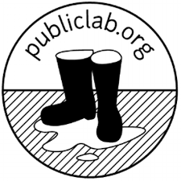

**Table of Contents:**

Introduction: 4

Specifications: 4

Input Image Format options: 4

Output Options: 4

Color Scheme – RGBA: 4

Image coordinates: 4

Processing Environment: 5

Image Modules: 5

Add-qr-module: 6

Average-module: 7

Blend-module: 8

Blur-module: 9

Brightness-module: 10

Channel-module: 11

Color Temperature: 12

Color-bar-module: 13

Colormap-module: 14

Contrast-module: 16

Convolution-module: 17

Crop-module: 18

DecodeQr-module: 20

Detect Edges: 20

Dither-module: 21

Draw-rectangle-module: 22

Dynamic-module: 23

Exposure: 25

FisheyeGl-module: 25

Flipimage-module: 26

Gamma-correction-module: 27

Gradient-module: 27

Grid Overlay: 28

Import-image-module: 30

Invert-module: 30

NDVI-module: 31

NDVI-colormap-module: 31

Overlay-module: 32

Paint-bucket-module: 33

Resize-module: 34

Replacecolor-module: 37

Rotate-module: 38

Saturation-module: 39

Text-overlay: 41

Threshold: 41

Tint: 42

White Balance: 43

Applications: 45

NDVI (NIR and Red) with colorbar: 45

# Introduction:

This manual provides instruction for the web browser applications of [Image Sequencer](https://publiclab.org/image-sequencer). The user manual consists of specifications, a description of the modules and an applications section which describes how the modules, when combined, can be used for different types of image analysis.

# Specifications:

## Input Image Format options:

Jpg (freezes and locks up )

Jpeg

png

Gif

canvas

Max Image Size : 1Mb?

(processing time vs file size)

Bit depth ??

Color and black/white

Maximum length and width size?

## Output Options:

PNG

GIF of sequences

## Color Scheme – RGBA:

Color is represented as as ‘tuple’ in (R,G,B) format. Each color channel has a value between 0 and 255.

black is: (0,0,0),

white is (255,255,255)..

red is (255,0,0).

blue is (0,0,255).

‘A’ represents transparency with values 0 to 255.

## Image coordinates:

Coordinates in (X,Y), which is (0,0) is located at the top left of the image

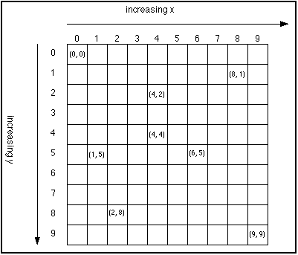 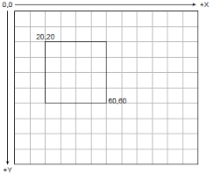

## Processing Environment:

(What is the processing environment ???)

(processing time vs file size)

# Image Modules:

Image Sequencer uses modules that perform a variety of step-by-step image processing tasks. Figure x describes the general workflow.

This section describes each module and a general implementation example Most examples used Figure X as the input reference image.

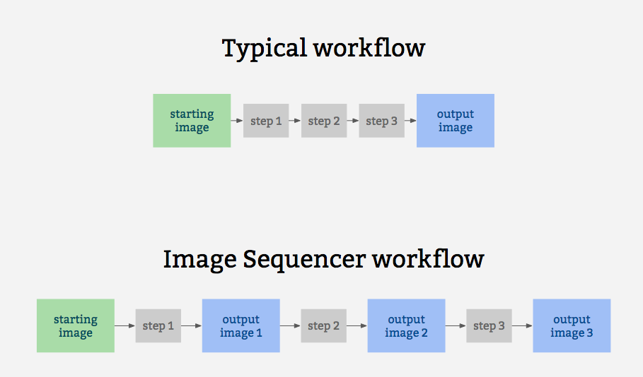

Figure Y Reference Image: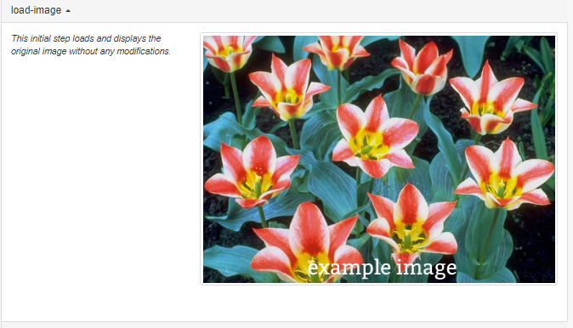

Additional information on the modulesand other operating modes can be found at the Image Sequencer github site. <https://github.com/publiclab/image-sequencer/tree/main/docs>

<https://github.com/publiclab/image-sequencer/blob/main/README.md>

## Add-qr-module:

This module adds a QR code to the image that corresponding to an imput string.

Usage:

sequencer.loadImage('PATH')

.addSteps('add-qr',options)

.run()

where options is an object with the following properties:

* size : size of QR code in pixels (default 200)
* qrCodeString : input string to generate QR code

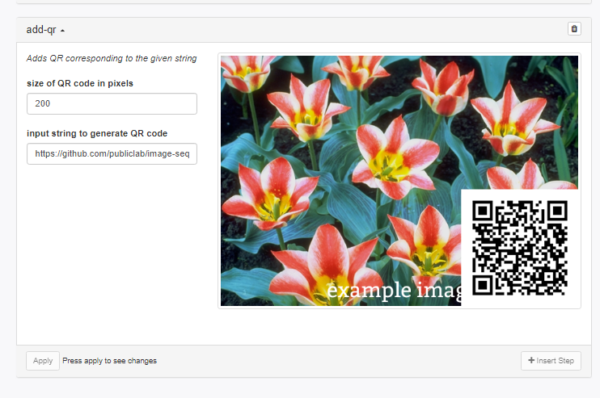

## Average-module:

This module is used for averaging all the pixels of the image.

Usage:

sequencer.loadImage('PATH')

.addSteps('average',options)

.run()

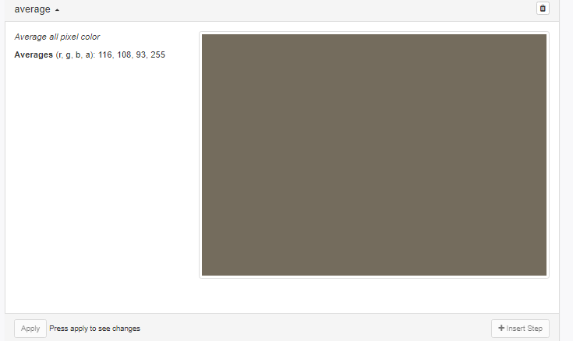

## Blend-module:

This module is used for blending two images . *Blend two chosen image steps with the given function. Defaults to using the red channel from image 1 and the green and blue and alpha channels of image 2.*

Usage:

sequencer.loadImage('PATH')

.addSteps('blend',options)

.run()

where options is an object with the following properties:

* offset: step of image with which current image is to be blended(Two steps back is -2, three steps back is -3 etc; default -2)
* func: function used to blend two images (default : function(r1, g1, b1, a1, r2, g2, b2, a2) { return [ r1, g2, b2, a2 ] })

For this example it is necessary to import a second image.

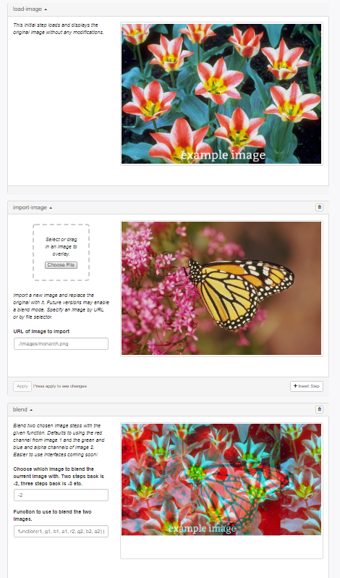

## Blur-module:

This module is used for applying a Gaussian blur effect.

Usage:

sequencer.loadImage('PATH')

.addSteps('blur',options)

.run()

where options is an object with the following property:

* blur : Intensity of Gaussian blur (0 to 5; default 2)

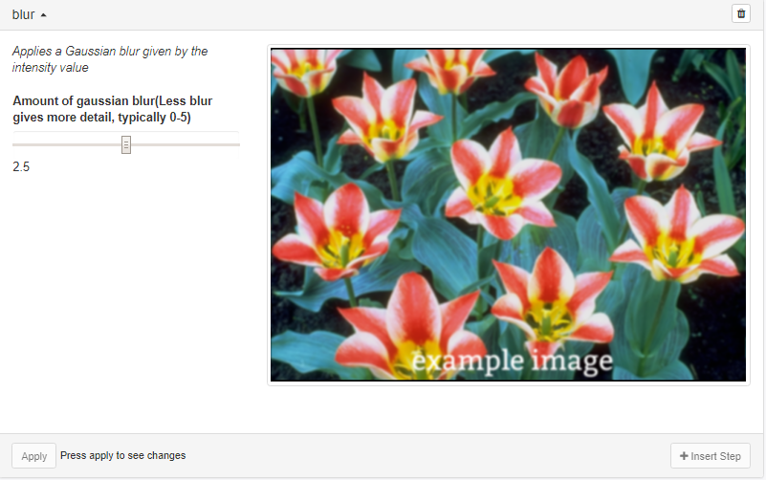

## Brightness-module:

This module is used for changing the brightness of the image.

Usage:

sequencer.loadImage('PATH')

.addSteps('brightness',options)

.run()

where options is an object with the following property:

* brightness : brightness of the image in percentage (0 to 100; default 100)

**note: sliders goes to 200? Not 100**

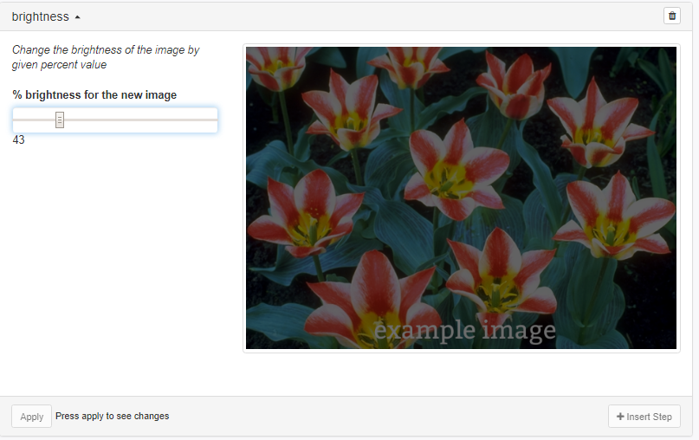

## Channel-module:

This module is used for forming a grayscale image by applying one of the three primary colors.

Usage:

sequencer.loadImage('PATH')

.addSteps('channel',options)

.run()

where options is an object with the following property:

* channel : color of the channel (red, green, blue; default green)

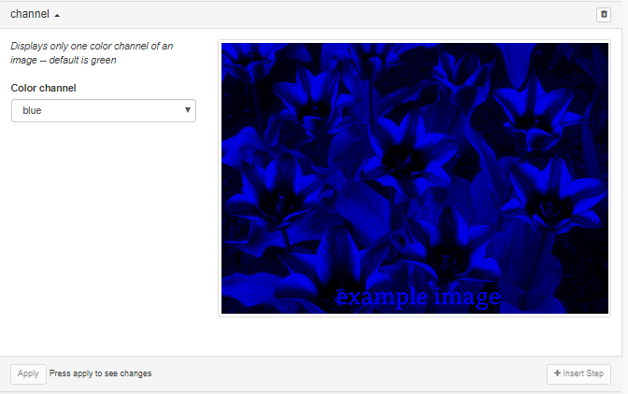

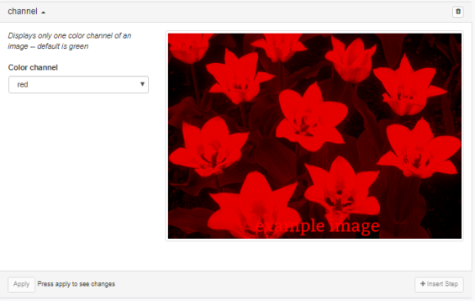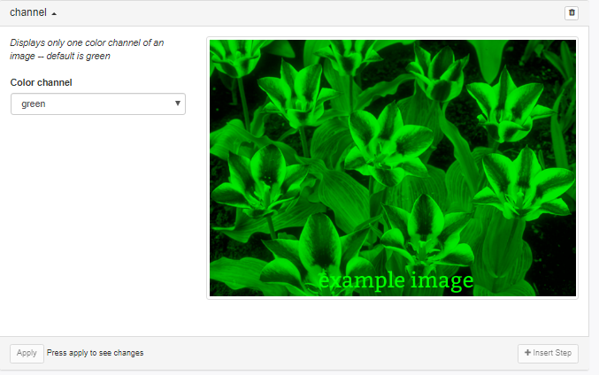

## Color Temperature:

This changes the color temperature of the image.

Usage:

sequencer.loadImage('PATH')

.addSteps('color-temperature',options)

.run()

where options is an object with the following property:

* temperature : temperature between 0 - 40,000 kelvin (default 6000)

Color temperature AT 100, 1000, 10,000 and 30000.

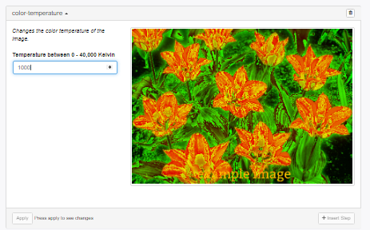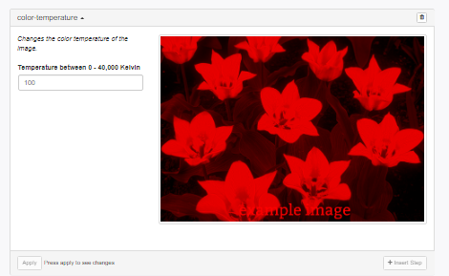

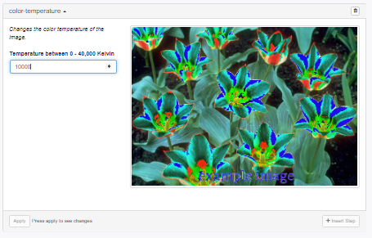 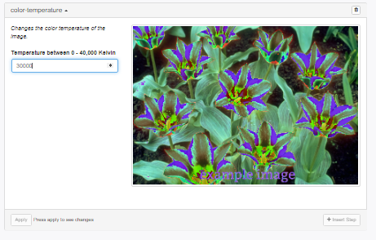

## Color-bar-module:

This module is used for displaying an image with a colorbar.

Usage:

sequencer.loadImage('PATH')

.addSteps('colorbar',options)

.run()

where options is an object with the following properties:

* colormap : Name of the Colormap(default, greyscale, stretched, fastie, brntogrn, blutoredjet, colors16; default: default)
* x : X-position of the image on which the new image is overlayed (default 0)
* y : Y-position of the image on which the new image is overlayed (default 0)
* h : height of resulting cropped image (default : 50% of input image width )

Could not get colorbar to work

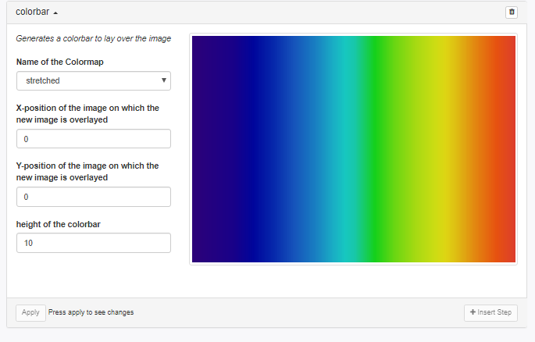

## Colormap-module:

This module is used for mapping brightness values (average of red, green & blue) to a given color lookup table, made up of a set of one more color gradients.

Usage:

sequencer.loadImage('PATH')

.addSteps('colormap',options)

.run()

where options is an object with the following property:

* colormap : Name of the Colormap ( greyscale, stretched, fastie, brntogrn, blutoredjet, colors16)

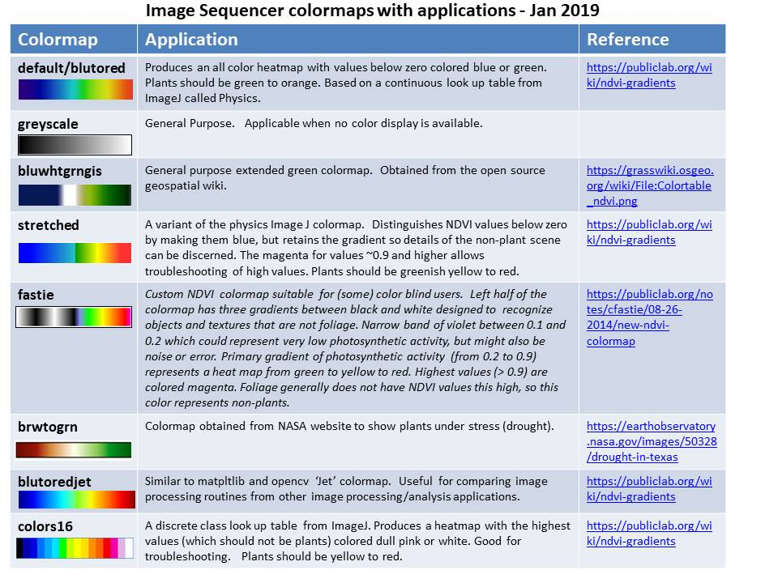

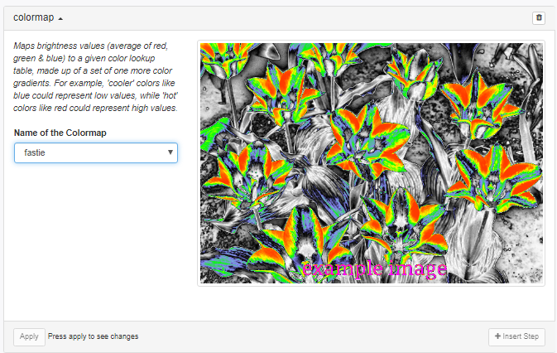

## Contrast-module:

This module is used for changing the contrast of the image.

Usage:

sequencer.loadImage('PATH')

.addSteps('contrast',options)

.run()

where options is an object with the following property:

* contrast : contrast for the given image (-100 to 100; default : 70)

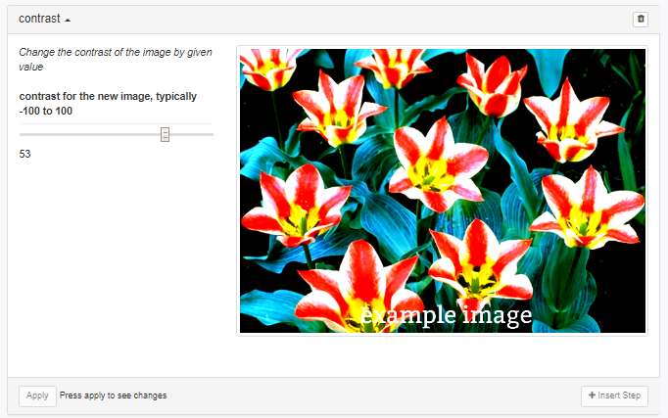

## Convolution-module:

This module is used for performing image-convolution.

Usage:

sequencer.loadImage('PATH')

.addSteps('convolution',options)

.run()

where options is an object with the following properties:

* constantFactor : a constant factor, multiplies all the kernel values by that factor (default : 1/9)
* kernelValues : nine space separated numbers representing the kernel values in left to right and top to bottom format(default : 1 1 1 1 1 1 1 1 1)

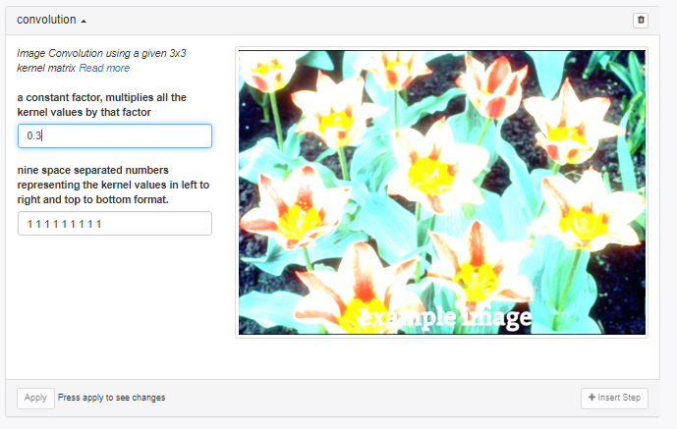

## Crop-module:

This module is used to crop an image.

Usage:

sequencer.loadImage('PATH')

.addSteps('crop',options)

.run();

Where options is an object having the properties x, y, w, h. This diagram defines these properties:

[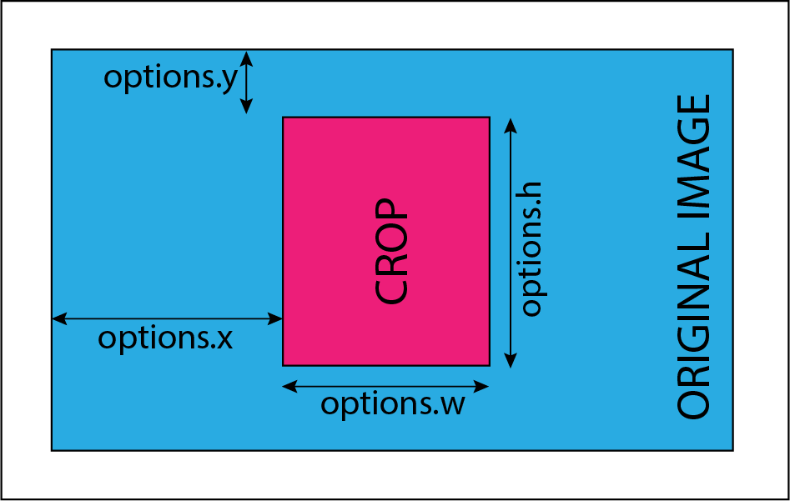](https://github.com/publiclab/image-sequencer/blob/main/docs/CropManual.png)

Defaults:

* options.x : 0
* options.y : 0
* options.w : half of image width
* options.h : half of image height

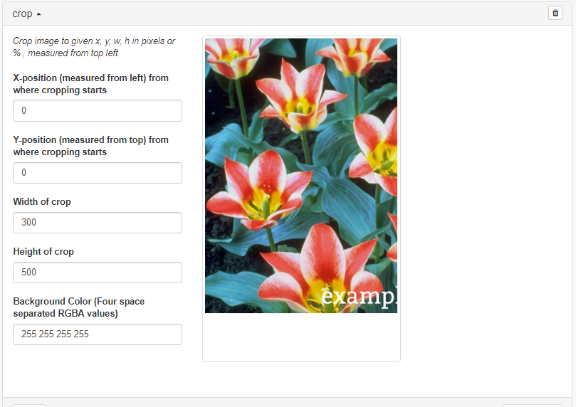

## DecodeQr-module:

This module is used for decoding a QR in image (if present).

Usage:

sequencer.loadImage('PATH')

.addSteps('decode-qr',options)

.run()

## Detect Edges:

This module detects edges using the Canny method, which first Gaussian blurs the image to reduce noise (amount of blur configurable in settings as `options.blur`), then applies a number of steps to highlight edges, resulting in a greyscale image where the brighter the pixel, the stronger the detected edge

This module is used for detecting images.

Usage:

sequencer.loadImage('PATH')

.addSteps('edge-detect',options)

.run()

where options is an object with the following properties:

* blur : Intensity of Gaussian blur (0 to 5; default 2)
* highThresholdRatio : Upper Threshold Ratio ( default : 0.2)
* lowThresholdratio : Lower Threshold Ratio ( default : 0.2)

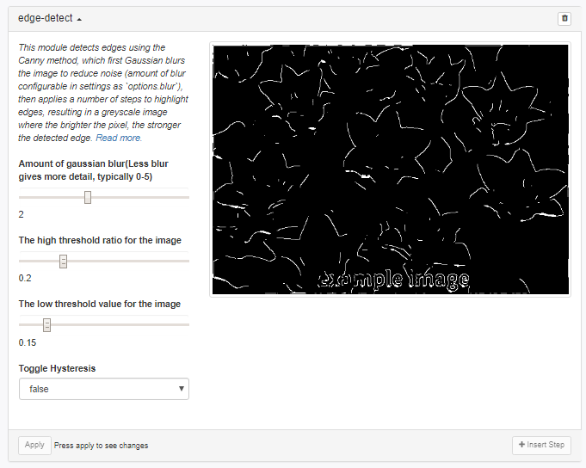

## Dither-module:

This module approximates a color from a mixture of other colors when the required color is not available, creating illusions of the color that is not present actually. (Not sure what this means)

Usage:

sequencer.loadImage('PATH')

.addSteps('dither',options)

.run()

where options is an object with the following property:

* dither : Can select the name of the Dithering Algorithm(default none)

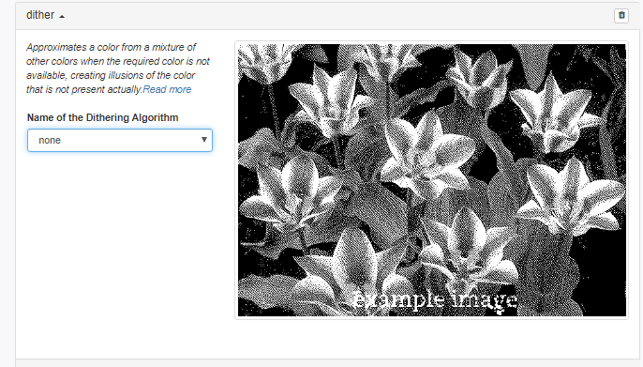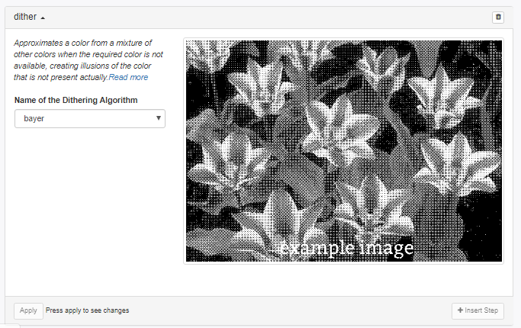

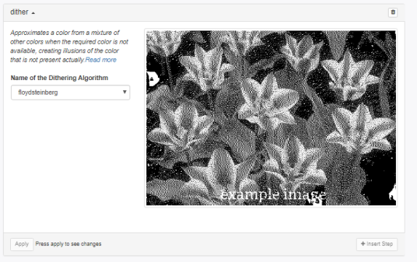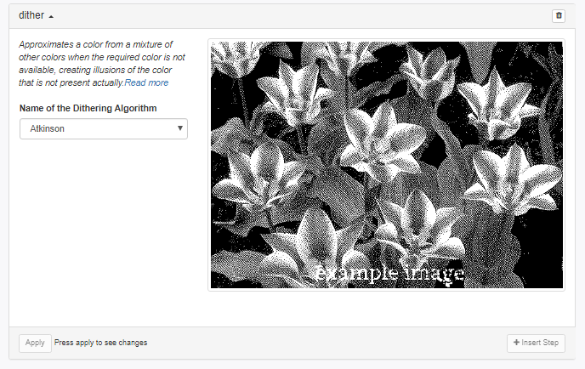

## Draw-rectangle-module:

This module helps to draw a rectangle on the image with a starting and ending corner with the specified thickness and color of the border.

Usage:

sequencer.loadImage('PATH')

.addSteps('draw-rectangle',options)

.run()

where options is an object with the following properties:

* startingX : starting x position of the rectangle (default 0)
* startingY : starting y position of the rectangle (default 0)
* endX : last x position of the rectangle (default "width")
* endY : last y position of the rectangle (default "height")
* thickness : thickness of the border (default 1)
* color : RGBA values separated by a space (default "0 0 0 255")

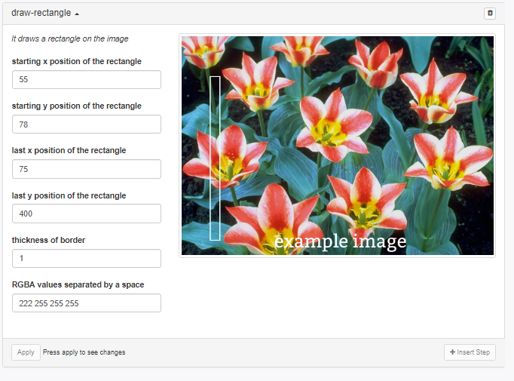

## Dynamic-module:

This module is used for producing each color channel based on the original image's color.

Usage:

sequencer.loadImage('PATH')

.addSteps('dynamic',options)

.run()

where options is an object with the following properties:

* red : expression for red channel (R, G, B and A as inputs; default r)
* green : expression for green channel (R, G, B and A as inputs; default g)
* blue : expression for blue channel (R, G, B and A as inputs; default b)
* monochrome: fallback for other channels if none provided (default : r+g+b/3)

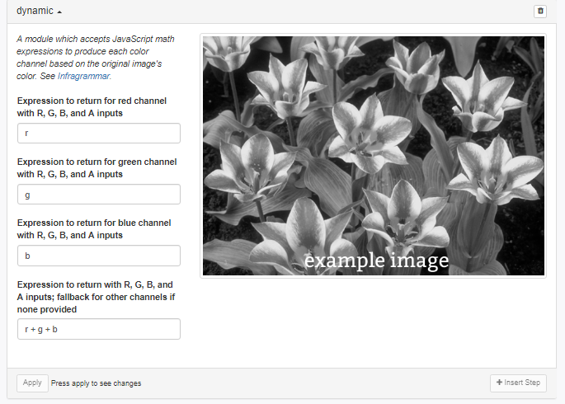

Is it r+g+b or r+g+b/3**?**

## Exposure:

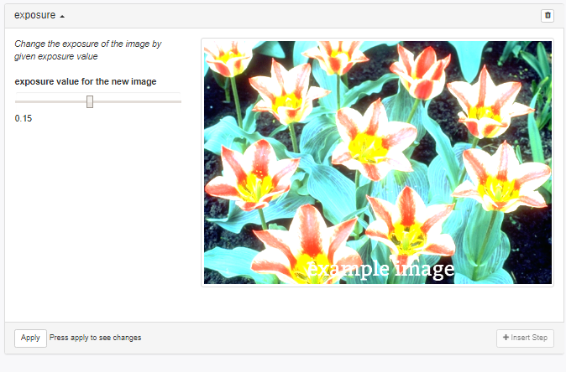

## FisheyeGl-module:

This module is used for correcting Fisheye or Lens Distortion

Usage:

sequencer.loadImage('PATH')

.addSteps('fisheye-gl',options)

.run()

where options is an object with the following properties:

* a : a correction (0 to 4; default 1)
* b : b correction (0 to 4; default 1)
* Fx : x correction (0 to 4; default 1)
* Fy : y correction (0 to 4; default 1)
* scale : The ratio to which the original image is to be scaled (0 to 20; default 1.5)
* x : Field of View x (0 to 2; default 1)
* y : Field of View y (0 to 2; default 1)

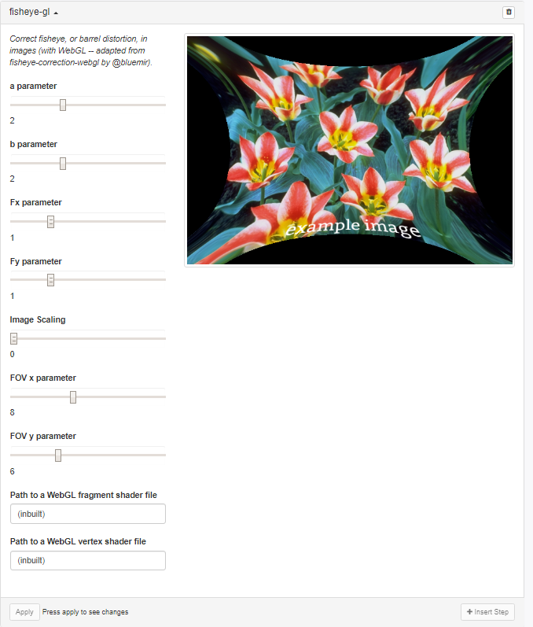

## Flipimage-module:

This module is used for flipping the image on the selected axis.

Usage:

sequencer.loadImage('PATH')

.addSteps('flip-image',options)

.run()

where options is an object with the following properties:

* 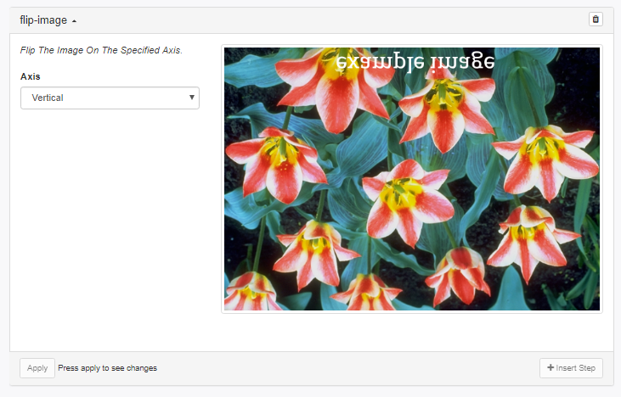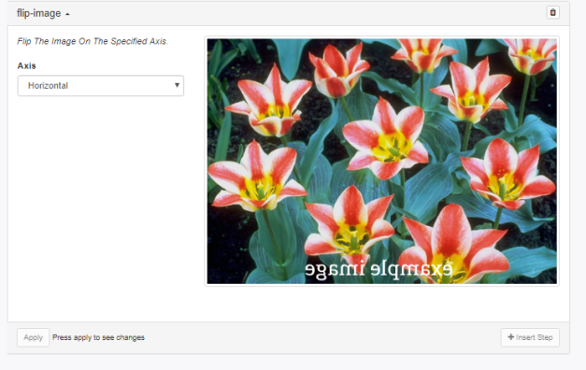Axis : select the required axis (default : vertical)

## Gamma-correction-module:

This module is used for applying gamma correction.

Usage:

sequencer.loadImage('PATH')

.addSteps('gamma-correction',options)

.run()

where options is an object with the following property:

* adjustment : Inverse of actual gamma factor (default 0.2)

(slider does not work)

## Gradient-module:

This module is used for finding gradient of the image.

Usage:

sequencer.loadImage('PATH')

.addSteps('gradient',options)

.run()

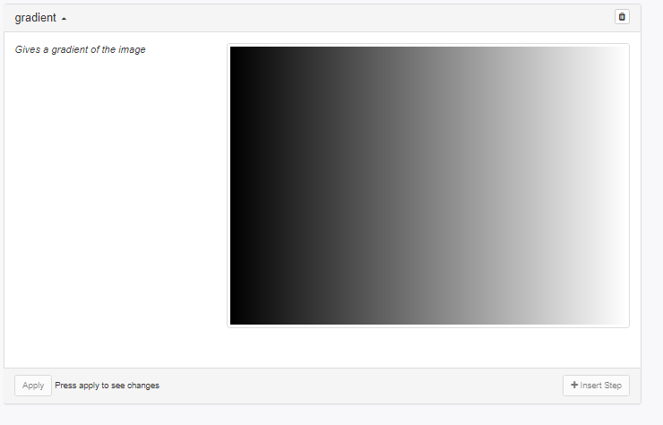

## Grid Overlay:

This adds the grid over an image.

Usage:

sequencer.loadImage('PATH')

.addSteps('grid-overlay',options)

.run()

where options is an object with the following property:

* options.x : The value at which the grid line should start in x-axis.
* options.y : The value at which the grid line should start in y-axis.
* color : Color for the grid on the image.

(only works once)

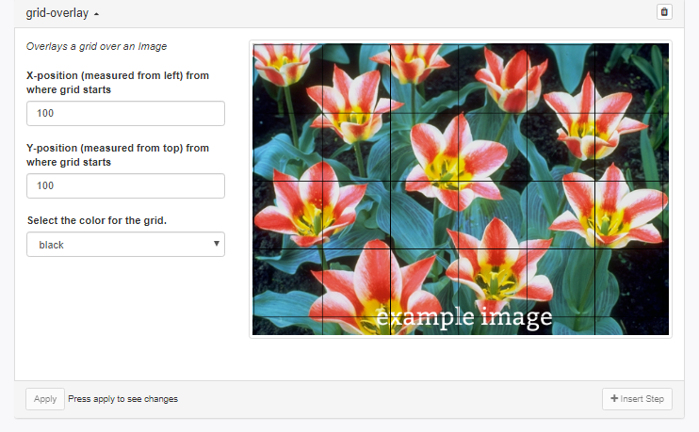Histogram-module:

This module is used for calculating histogram of the image.

Usage:

sequencer.loadImage('PATH')

.addSteps('histogram',options)

.run()

where options is an object with the following property:

* gradient : boolean value used to toggle gradient along x-axis (true or false; default true)

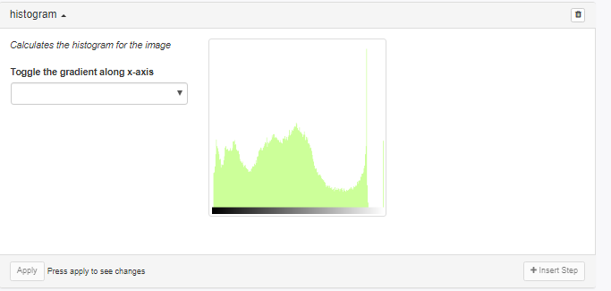

## Import-image-module:

This module is used for importing a new image and replacing the original with it.

Usage:

sequencer.loadImage('PATH')

.addSteps('import-image',options)

.run()

where options is an object with the following property:

* url : url of the new image (local image url or data url;default : "./images/monarch.png")

## Invert-module:

This module is used for inverting the image.

Usage:

sequencer.loadImage('PATH')

.addSteps('invert',options)

.run()

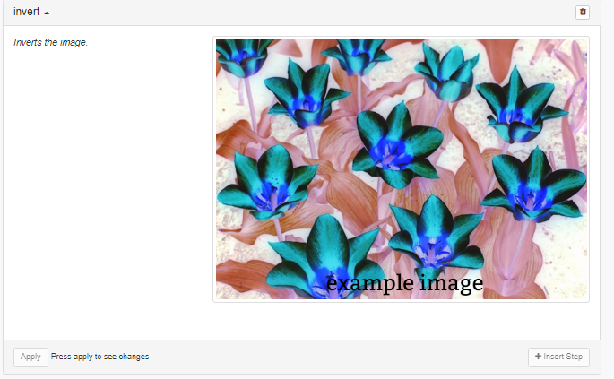

## NDVI-module:

This module is used for applying ndvi technique to the image.

Usage:

sequencer.loadImage('PATH')

.addSteps('ndvi',options)

.run()

where options is an object with the following property:

* filter : filter for NDVI (blue or red; default red)

## NDVI-colormap-module:

This module is used for demonstrating ndvi and colormap properties consecutively.

Usage:

sequencer.loadImage('PATH')

.addSteps('ndvi-colormap',options)

.run()

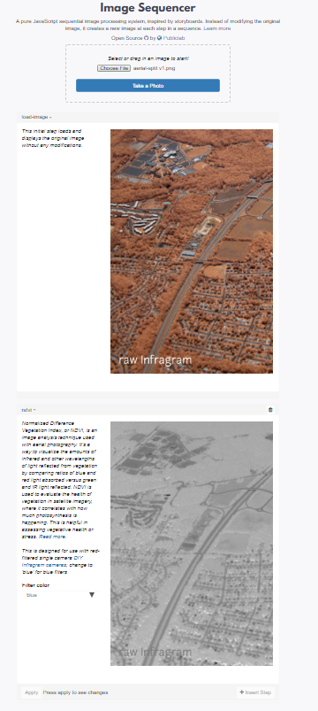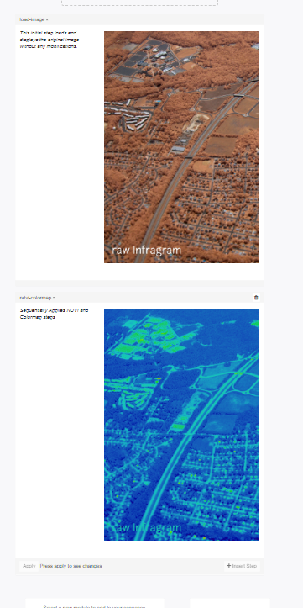

## Overlay-module:

This module is used for overlaying an Image over another .

Usage:

sequencer.loadImage('PATH')

.addSteps('overlay',options)

.run()

where options is an object with the following properties:

* x : X-position of the image on which the new image is overlayed (default 0)
* y : Y-position of the image on which the new image is overlayed (default 0)
* offset : offset to the step on which the output of the last step is overlayed (default -2)

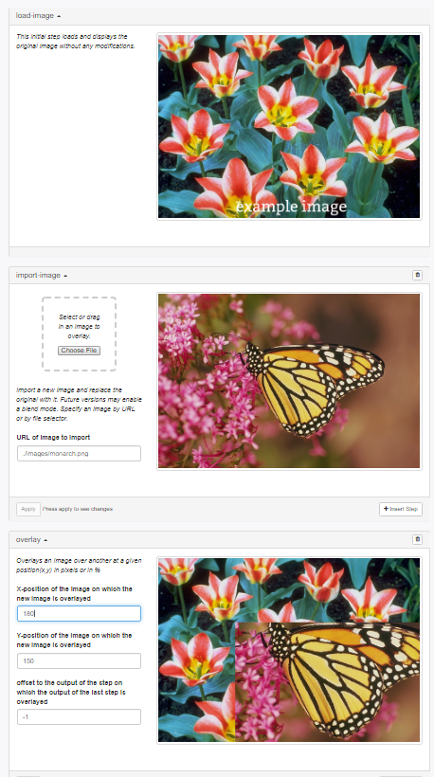

## Paint-bucket-module:

This module fills any polygonal shape with the specified color in pixels.

Usage:

sequencer.loadImage('PATH')

.addSteps('paint-bucket',options)

.run()

where options is an object with the following property:

* startingX : it is the value of the starting x-cordinate (default 10)
* startingY : it is the value of the starting y-cordinate (default 10)
* fillColor : they are four spaced seperated numbers representing the RGBA values of fill-color (default "100 100 100 255")
* tolerance : it is the % tolerance (default 10)

(does this work, all images seem the same)

## Resize-module:

This module is used for resizing an image.

Usage:

sequencer.loadImage('PATH')

.addSteps('resize',options)

.run()

where options is an object with the following property:

* resize : Percentage value of resize (default 125%)

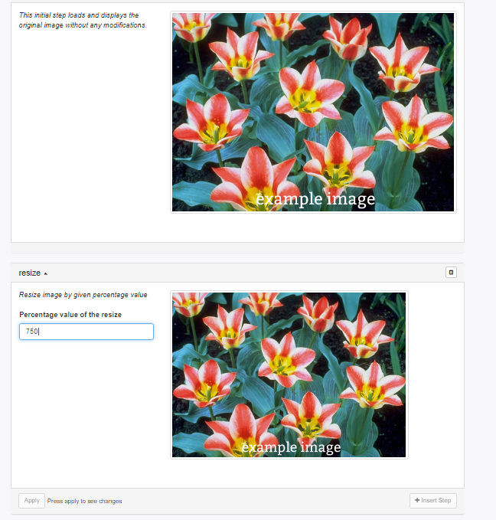

(is this off by 100?)

Resize-canvas:

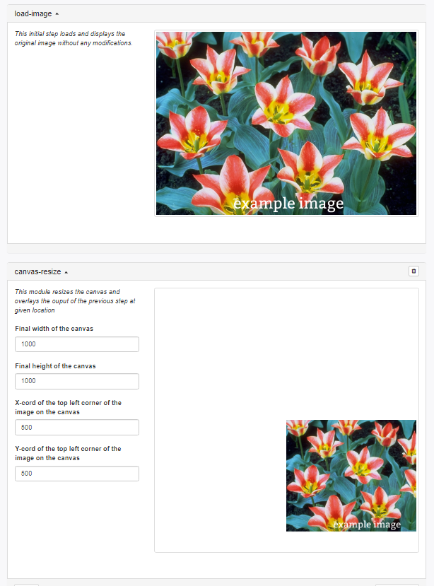

## Replacecolor-module:

This module is used in replacing the color with grey or any desired color.

Usage

sequencer.loadImage('PATH')

.addSteps('replace-color',options)

.run()

where options is an object with the following properties:

* replaceMethod : replaces with the desired color (default greyscale)
* replaceColor : three space separated numbers representing the RGB values of color to be filled (default "0 0 255")
* color : three space separated numbers representing the RGB values of color to be replaced (default "228 86 81")
* tolerance : it is the % tolerance (default 50)

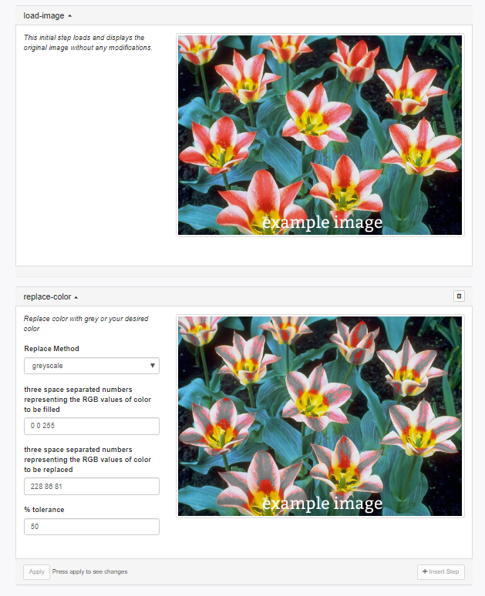

## Rotate-module:

This module is used for rotating an image.

Usage:

sequencer.loadImage('PATH')

.addSteps('rotate',options)

.run()

where options is an object with the following property:

* rotate : angular value for rotation in degrees (between 0 and 360; default 0)

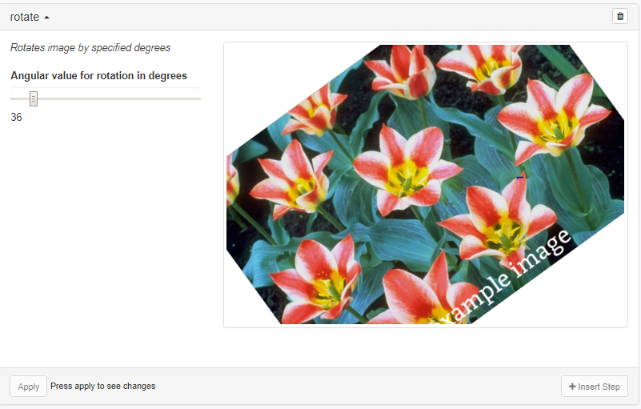

## Saturation-module:

This module is used for changing the saturation of the image.

Usage:

sequencer.loadImage('PATH')

.addSteps('saturation',options)

.run()

where options is an object with the following property:

* saturation : saturation for the new image (between 0 and 2; default 0)

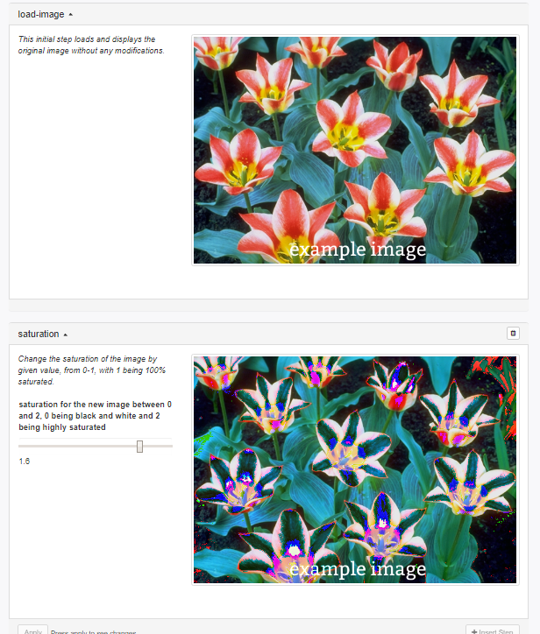

## Text-overlay:

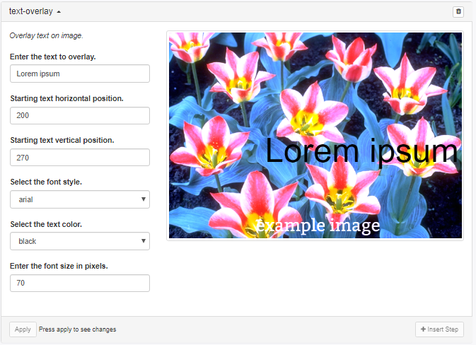

## Threshold:

Thresholding is used to create binary images.

Usage:

sequencer.loadImage('PATH')

.addSteps('threshold',options)

.run()

where options is an object with the following property:

* threshold : it allows to select the types of thresholding (default "manual thresholding")
* input : it allows to select the range of thresholding value (default 120)

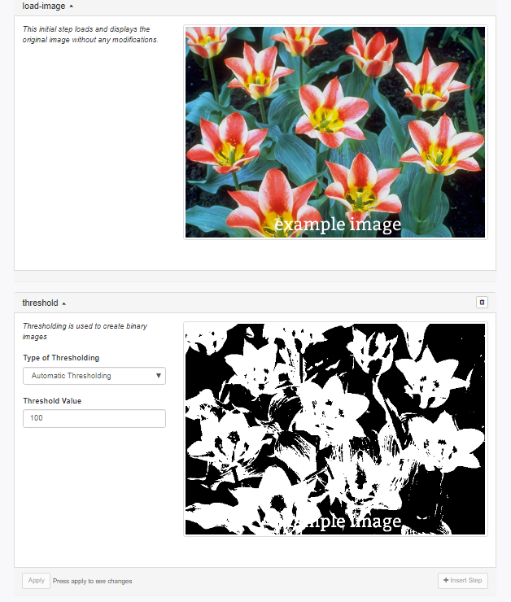

## Tint:

It adds color tint to an image.

Usage:

sequencer.loadImage('PATH')

.addSteps('tint',options)

.run()

where options is an object with the following property:

* color : RGB values seperated by a space (default "0 0 255")
* factor : amount of tint (default 0.5)

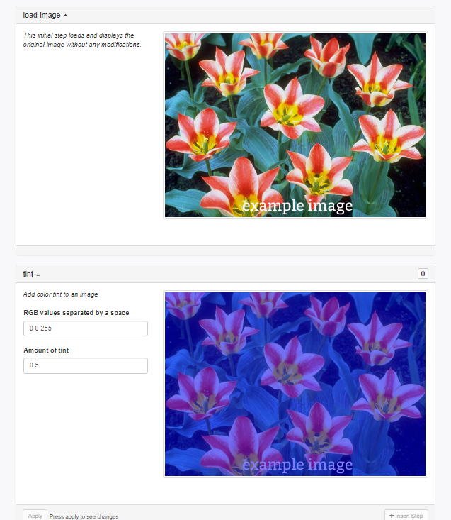

## White Balance:

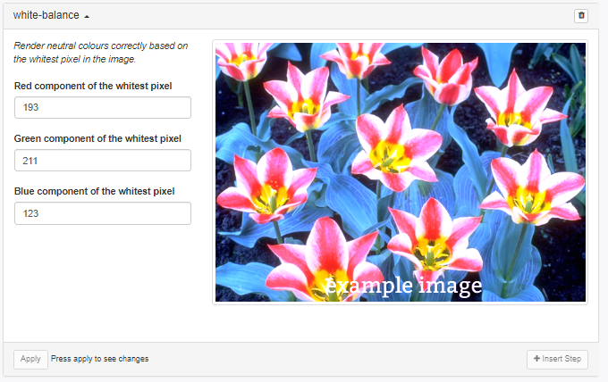

# Applications:

This section demonstrates how Image Sequencer modules can be applied for different applications.

## NDVI (NIR and Red) with colorbar:

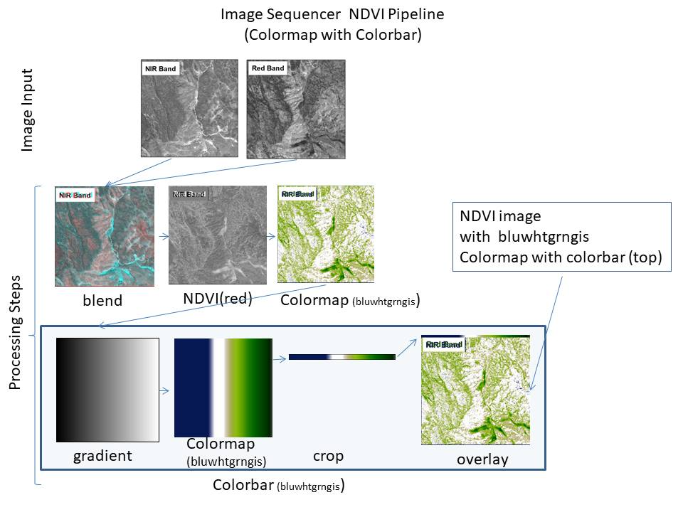

----------------------------------------------------------------------------------------

**t**